|  |  |  |
| --- | --- | --- |
| **ISYS/COMP355 2013 S1** | **User Manual - Group 5** |  |
|  |  |

**ISYS/COMP355**

**Fire Truck Game User Manual**

**Group 5**



Written By: Edward Moore, Tim Brewster, James Cole, Eric Mare, Rocky Liu & Mohsen Hokmabadi

|  |  |  |
| --- | --- | --- |
| **Versions** | | **3** |
| **References** | | **4** |
| **1.0** | [**Introduction**](#page6) **to User Manual** | **5** |
| [**1.1**](#page11) **About Fire Truck Game** | | **5** |
| [**1.2**](#page11) **User Manual Scope** | | **6** |
| [**1.3**](#page11) **Instructions For Use** | | **6** |
| **2.0** | **Implementation of Principles** | **7** |
| [**3.0**](#page11) **Passwords & Maintenance** | | **8** |

**Versions**



|  |  |  |
| --- | --- | --- |
| **Version #** | **Author** | **Notes** |
| 0.1 | Eric | Initial design of document |
| 0.3 | Eric | Creation of user manual scope & password maintenance |
| 0.5 | James | Creation of introduction & about fire truck game |
| 0.8 | Tim | Creation of good game principle implementations |
| 1.0 | All | Final review & minor changes |

**References**

|  |  |  |  |  |
| --- | --- | --- | --- | --- |
| **Resource** | **Author** | **Date** | **Title** | **Source** |
| MacICT Logo | MacICT | 07/03/2013 | MacICT Logo | http://macict.edu.au/ |
| MacICT Class Photo | MacICT | 08/03/2013 | MacICT Class Photo | http://macict.edu.au/ |
| Designer Scorecard | MacICT | 08/03/2013 | Designer Scorecard | Cathie Howe |
| MacICT Project Plan | Group 5 | 24/05/2013 | MacICT Project Plan | Group 5 |



**1.0 Introduction to User Manual**

This user manual is a document containing information on the software application that has been created as a collaboration between MacICT and Macquarie University. The document is intended to educate teachers on how to play the game while at the same time, providing knowledge on how the game reinforces the concepts of good game design that are demonstrated in MacICT’s boot camps.

This document is intended for the use of teachers of MacICT boot camps, as well as teachers and other pedagogical practitioners who have had their class attend a MacICT boot camp. The document will aid the teachers in being able to demonstrate to their students on how to play the game. Furthermore, to make the most educational benefit of the game, this document instructs teachers on how the good game design principles are purposely removed throughout the game’s execution. This document also defines the technical requirements needed to play the game.

**1.1 About Fire Truck Game**

The game was created as a result of discussions made with Cathy Howe from MacICT. Cathy was in need of a game, aimed at students aged 6-15 who had attended the MacICT boot camp on good game design principles. The game was to have elements in it, as pre-determined by the Designer Scorecard (Appendix 1). These elements can be considered as the success factors for the game and are used by students to help them in analysing different features of a game and ultimately determine what makes a game great.

The fire truck game has been effectively designed to the meet needs of the balanced scorecard and good game principles. The game addresses these components through utilising game features to deliberately demonstrate the differences between a game built without good game principles to transform a good game into a purposely made dysfunctional game.

Such features that have been incorporated into the fire truck game include deliberate spelling & grammar mistakes in story highlights, technical mistakes that affect the running of the game and purposely cause errors, with further element such as a limited world, significant changes in challenges & difficulty curves, little back story details and purposely giving varying player feedback for tasks which may confuse the player. The ability for the fire truck game to highlight these components effectively demonstrates good game principles and provides a mechanism for learning and reinforcement of good

game principles by a effective contrast between a game that operates as expected and game that has been purposely designed to include errors.

**1.2 User Manual Scope**

The scope of the user manual covers the following aspects of the fire truck game and the fire truck game website;

* The implementation of good game principles and how the game can effectively teach and demonstrate good game principles.
* Instructions on setting up user access password lists.

**1.3 Instructions for Use**

The game is controlled entirely by the mouse. This makes the game accessible and intuitive for the user. It also makes demonstrating the game to students within a class a simple task.

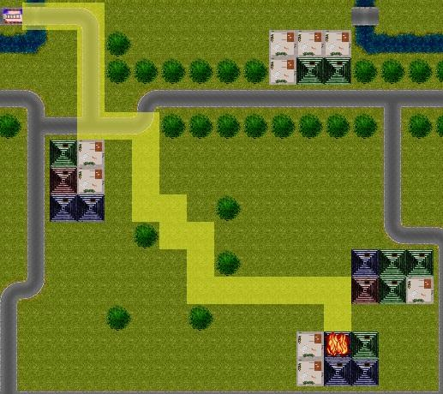As can be seen by Figure 1 below, the cursor is selected on or around the fire truck and then dragged to the destination that the controller wishes to send the fire truck. To handle multiple fires that occur throughout the game, multiple fire trucks can be sent out from the ‘Fire Rescue’ building.

**Figure 1** – Fire Truck Game UI

**2.0 Implementation of Principles**

Implementation of Good Game Principle For each of the principles listed in the ‘Designer Scorecard’, there are elements that facilitate the success of a game. Many of these were purposely left out, or created poorly in order to highlight the negative impact that poor game design has. The principles and how they were (or weren’t as the case may be) implemented are listed below:

* Technical: the game appears as though it freezes at certain points of execution.
* Spelling & Grammar: Spelling errors occur throughout the game’s execution in the ‘Newsfeed’ at the bottom of the game’s canvas.
* Story: Little story behind the actual gameplay, thus lacking engagement and attachment to the user.
* World: the setting of the game is not completely in line with the story.
* Challenge and Difficulty Curve: The game begins as easy and then as it progresses, the difficulty becomes practically impossible - as a result of fires burning quicker than the fire trucks can drive.
* Player Feedback: Little to no feedback to the user.

These missing pieces in the game could be discussed with students as to the impact that they felt it had to their ingame experience.

Technical Environment The game is web based and runs on commonly accepted and industry standard protocols and languages. Thus the game is platform independent and can be executed on most systems that have a modern web browser installed.

The specific technical requirements to run the game are as follows: Operating Systems:

* Windows 7
* Mac OS X Mountain Lion
* iOS version 6.0 (iPad/iPhone)
* Android 4.2 (Tablet/Phone)

Web browsers:

* Firefox version 21.0.1
* Internet Explorer version 10.0.01
* Safari version 6.0.3
* Google Chrome version 26.0.1410.64 m

**3.0 Passwords & Maintenance**

**Changing Keys**

To update the Keys for the game do the following steps

1. Login into FTP through webfactional
2. Go into WebApps/Firetruck
3. Open game.php in an Editor (such as Dreamweaver)
4. Modify key list at the top of the page, there is no limit to how many keys you can have.
5. Save and quit.

* All changes should be instant.
* Keys can contain Upper & Lower case Alpha, numbers, symbols (not tested with ‘$’).
* Keys Must follow the pattern xxx-xxxx-xxx

If you have any trouble please email [edward.moore@students.mq.edu.au](mailto:edward.moore@students.mq.edu.au)

**Creating Levels**

Because the game as a framework, designing levels is very easy, so easy that students who have completed the game could create their own levels. I have included details below on how to do this.

Data for the level (what goes where). Covered below

The level design looks like this.

Level number (starts from 0)

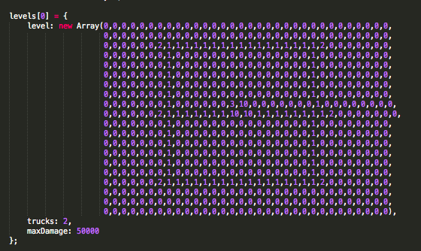

Maximum damage before losing level

Number of trucks allowed

The table showing what number represents what element is below.

|  |  |  |
| --- | --- | --- |
| Number | Element | Preview |
| 0 | Grass | Macintosh HD:Users:emoore:Documents:Firetruck_Alpha:images:sprites:grass.png |
| 1 | Road | Macintosh HD:Users:emoore:Documents:Firetruck_Alpha:images:sprites:road_h1.png |
| 2 | House | Macintosh HD:Users:emoore:Documents:Firetruck_Alpha:images:sprites:building_3.png |
| 3 | Fire Station | Macintosh HD:Users:emoore:Documents:Firetruck_Alpha:images:sprites:Firestation.png |
| 4 | Gas Station | Macintosh HD:Users:emoore:Documents:Firetruck_Alpha:images:sprites:gasstation.png |
| 5 | NOT USED |  |
| 6 | NOT USED |  |
| 7 | Tree | Macintosh HD:Users:emoore:Documents:Firetruck_Alpha:images:sprites:tree.png |
| 8 | River | Macintosh HD:Users:emoore:Documents:Firetruck_Alpha:images:sprites:river_h1.png |
| 9 | Bridge | Macintosh HD:Users:emoore:Documents:Firetruck_Alpha:images:sprites:river_b_v1.png |
| 10 | Special Block |  |

|  |  |
| --- | --- |
| 3 | 10 |
| 10 | 10 |

There is one special case when creating a level. When putting in a Fire Station, you must put in a Special Block to the left, below and left below. So it should look like this:

Once you have a level that has been designed, you can include it by doing the following:

1. Login into FTP through webfactional
2. Go into WebApps/Firetruck/JS
3. Open up levels.js in a editor (such as DreamWeaver)
4. Go to the bottom of the file
5. Copy the last level and update the details. When doing this make sure:
   1. Increment level number
   2. Don’t delete any commas (‘,’) or any other formatting that is in all the other levels.

**When editing levels, you should take great care as if you make a mistake (like removing an extra typo), you may stop the game working for everyone.**